**INSY5336-HOMEWORK 5**

**Due: April 30, on/before midnight CST**

**Delivery method: Blackboard**

Student Name: ________________________________

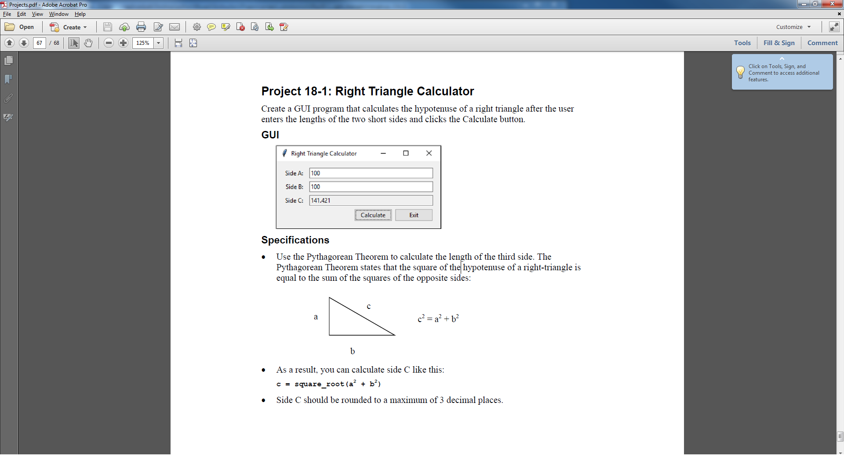

Note: Please name your program in this style: Lastname_HW5.py, and upload to blackboard.

Thank you.

## Homework Submission

1. You are required to submit your assignments electronically in Blackboard. Just click on the Assignment listing under the Assignments link. Download the assignment, complete the assignment, and upload your file. The link is available up to the due time/date.
2. You will follow the instructions for submission as specified on the homework description; i.e. naming conventions, zip conventions, etc.
3. Make sure to write your full name as a comment at the very beginning of each .py file submitted for grading.
4. Only homework submitted through Blackboard will be graded. Grades will be posted in Blackboard.

## Homework Grading

1. If your program does not compile, you will not receive more than 20% of the maximum points.
2. If your program compiles but does not execute, you will not receive more than 35% of the maximum points.
3. If your program compiles and executes yet does not give the required output, you will not receive more than 50% of the maximum points.
4. You will get the maximum points only if your program compiles properly and executes according to the requirements specified in the assignment.
5. You must name the .py files as specified or they will not be graded.
6. If you use Python constructs on assignments that we have not yet discussed in class, 20 points will be deducted.
7. If you do not adhere to our coding standards, 15 points will be deducted.